How to create add Subdomain in GoDaddy and Azure

Please follow the given steps to add Subdomain in GoDaddy and Azure

1. Login in to GoDaddy and create a CNAME record,
Note:-
HOST - should be your subdomain.
POINTS TO - should be your azure link, which is generated by azure for the web applications.

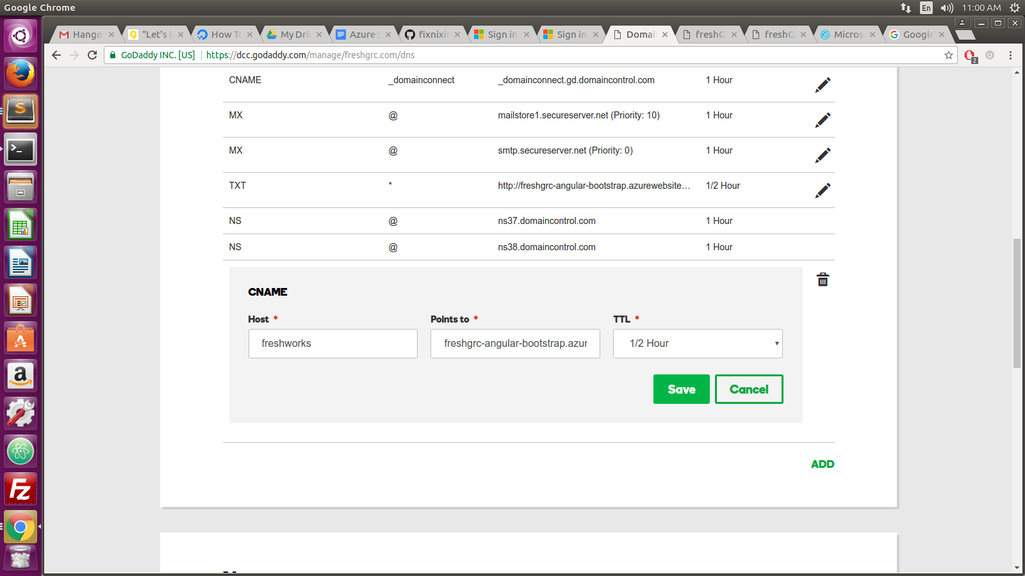
2. Login in to Azure and click the particular web applicaion and click “Custom Domains”

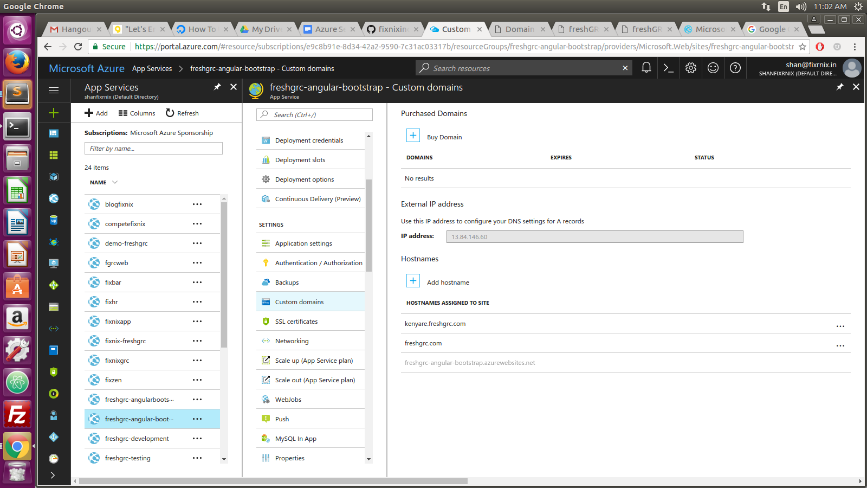

and click the “Add HostName” Button

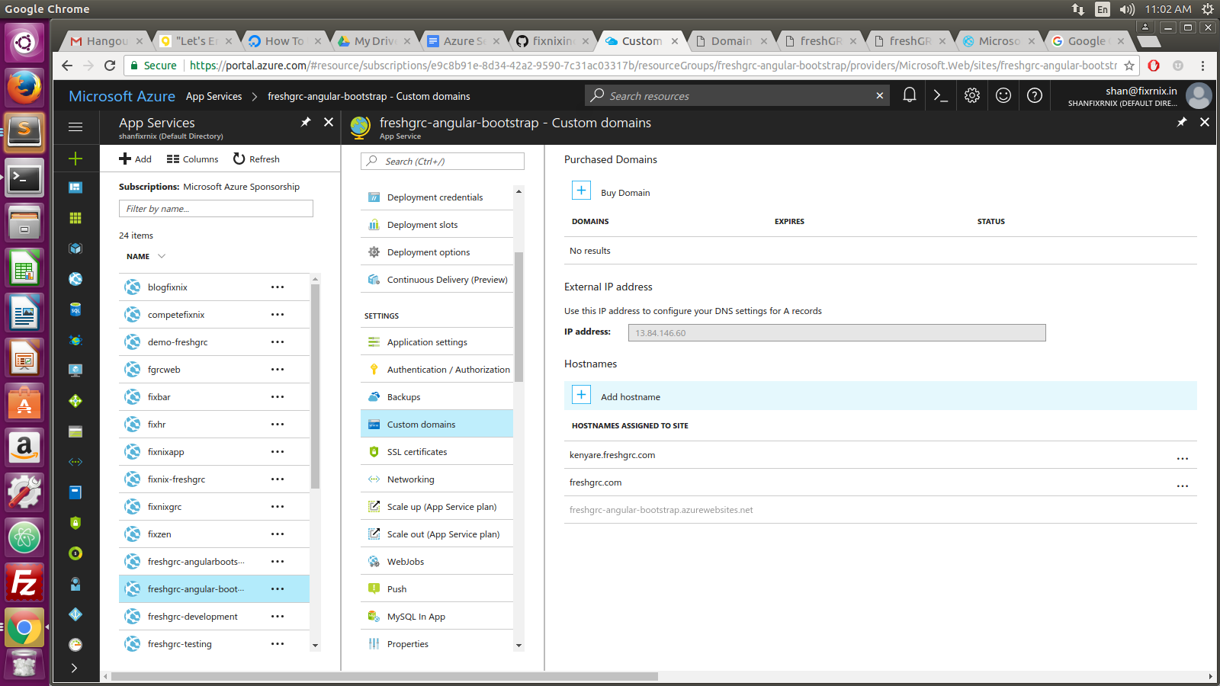
3. Enter your subdomain name with main domain name.
Note:-
Subdomain - freshworks
Maindomain - freshgrc.com, which is bought from GoDaddy and under this main domain, we add many subdomain.
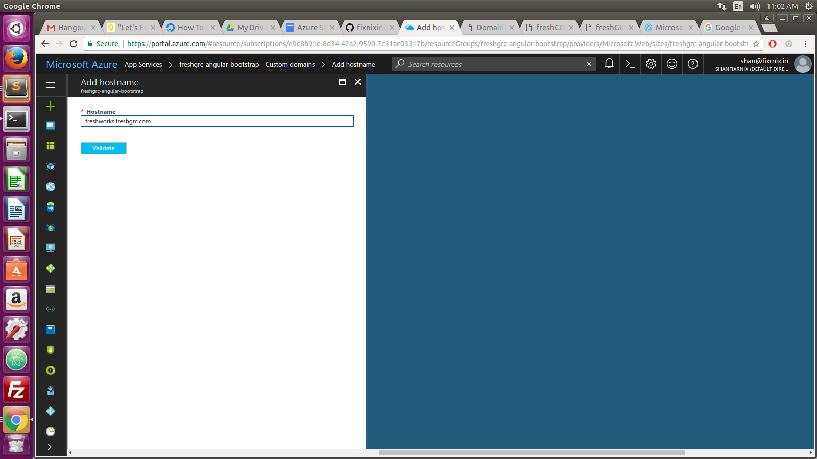

4. Click the “Validate” button, Once you clicked after some time Host/Domain availability should be green tick mark.

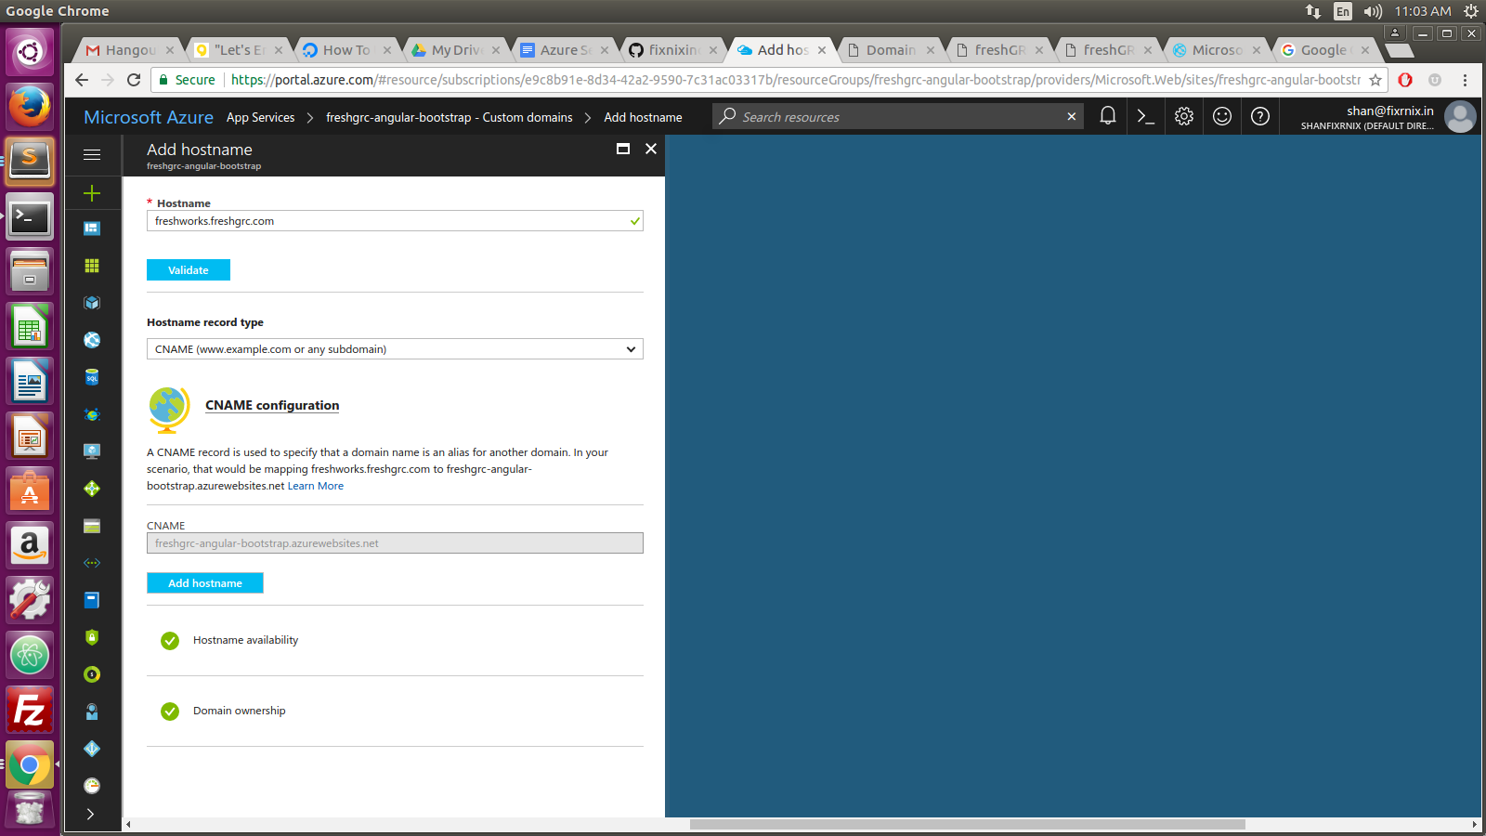
5. Click the “Add Host Name” button and it will automatically add to your subdomain
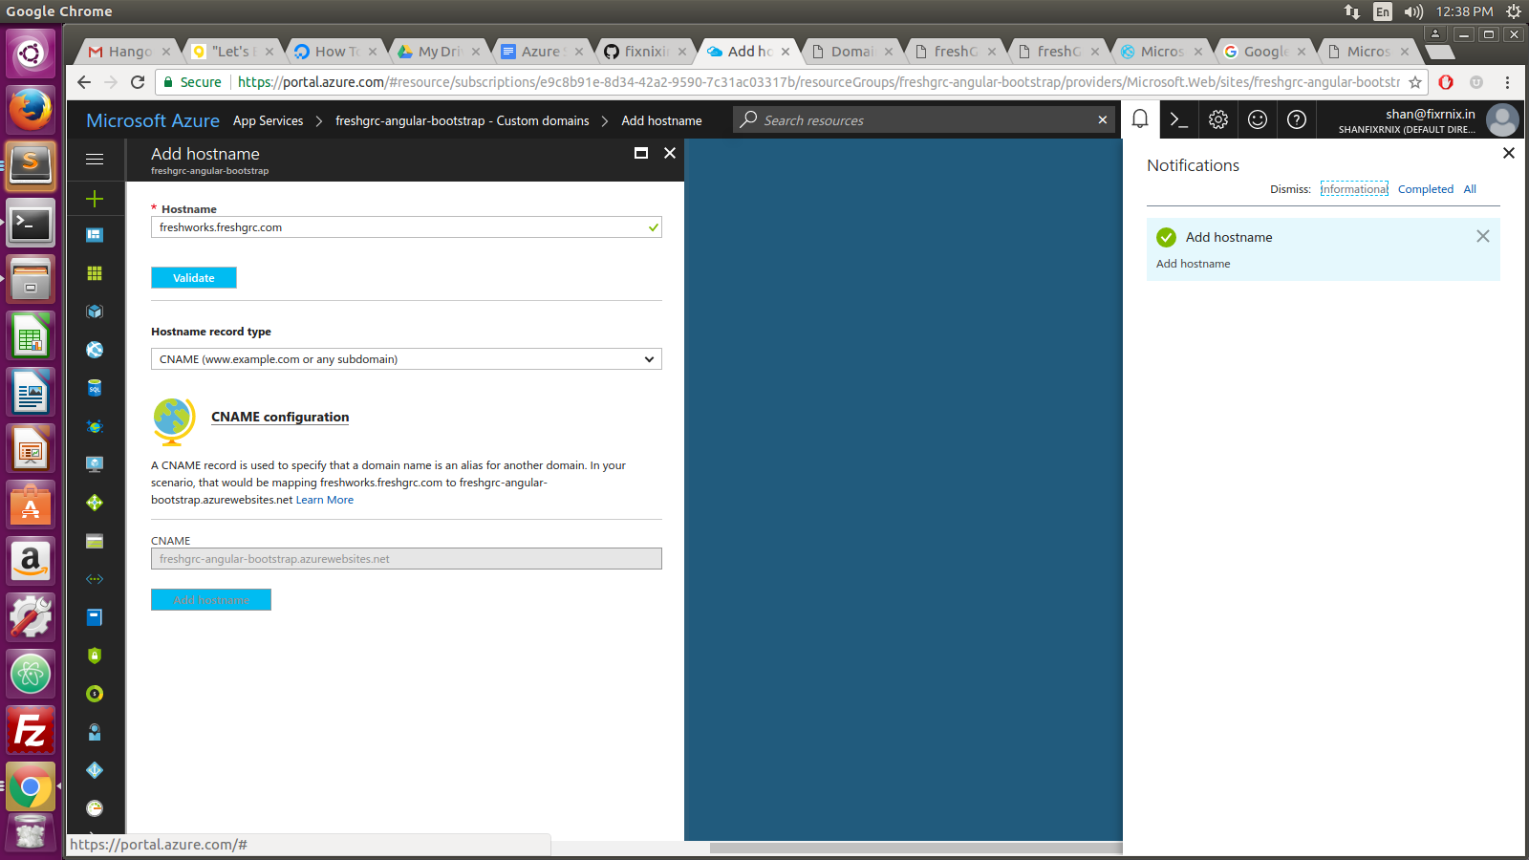

Finally you will get http://freshworks.freshgrc.com it will redirect to application.



